**Email LOGS**

1.Identify external email addresses that have sent emails to CNL users in the last 15 minutes.

**index="msexchange" sourcetype="MSExchange:2013:MessageTracking" sender!=*company_email* | table sender | dedup sender**

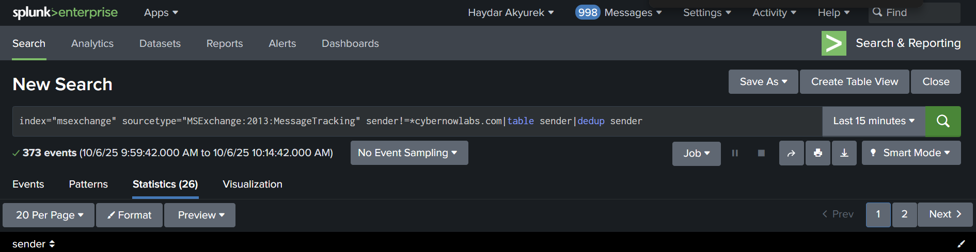

2. Identify external email addresses that have sent emails to more than one CNL user in the last 15 minutes.

**index="msexchange" sourcetype="MSExchange:2013:MessageTracking" sender!=*cybernowlabs.com| stats dc(recipient) as gelen by sender | where gelen > 1**

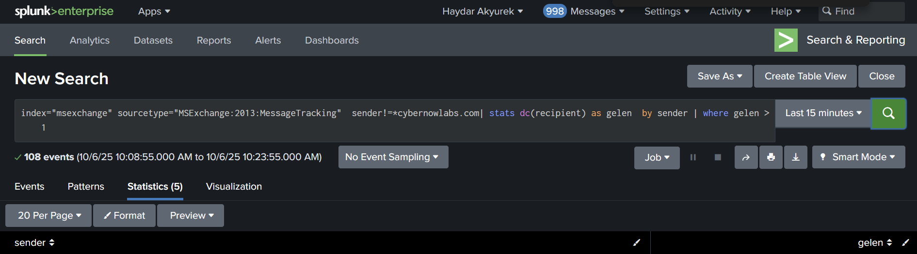

3. Identify external email addresses and email subjects that have sent emails to more than one CNL user in the last 15 minutes.

**index="msexchange" sourcetype="MSExchange:2013:MessageTracking" sender!=*cybernowlabs.com| stats dc(recipient) as gelen by sender message_subject | where gelen > 1 |table sender message_subject**

